A spirituality of resilience

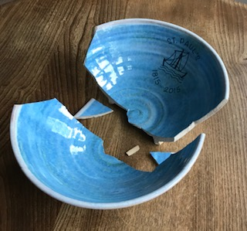
Anthem
The birds they sang
At the break of day
Start again
I heard them say
Don't dwell on what
Has passed away
Or what is yet to be
Ring the bells (ring the bells) that still can ring
Forget your perfect offering
There is a crack in everything (there is a crack in everything)
That's how the light gets in
Leonard Cohen (1934-2016)

Serenity prayer
God grant me the serenity
to accept the things I cannot change;
courage to change the things I can;
and wisdom to know the difference.

Reinhold Niebuhr (1892-1971)

The welcoming prayer
Welcome, welcome, welcome.
I welcome everything that comes to me today
because I know it's for my healing.
I welcome all thoughts, feelings, emotions, persons,
situations, and conditions.
I let go of my desire for power and control.
I let go of my desire for affection, esteem,
approval and pleasure.
I let go of my desire for survival and security.
I let go of my desire to change any situation,
condition, person or myself.
I open to the love and presence of God and
God's action within.

Father Thomas Keating

Abide in me as I abide in you. Just as the branch cannot bear fruit by itself unless it abides in the vine, neither can you unless you abide in me. I am the vine, you are the branches. Those who abide in me and I in them bear much fruit, because apart from me you can do nothing. John 15:4-5

I've learned that people will forget what you said, people will forget what you did, but people will never forget how you made them feel.
Maya Angelou 1928-2014

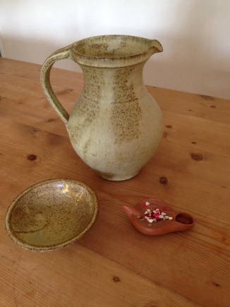

For further work see:

Nonviolent Communication (NVC) sometimes referred to as compassionate communication. A practice which guides us to reframe how we express ourselves and hear others by focusing on what we are observing, feeling, needing, and requesting

for the practice of silent meditation
World Community of Christian Meditation (WCCM)

