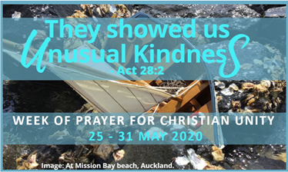

Aotearoa New Zealand
Commitment to Unity through Hospitality.

During the service, we are all invited to reflect on how we might commit to acts of hospitality, showing unusual kindness.
Reconciliation, Enlightenment, Hope, Trust, Strength, Hospitality, Conversion, Generosity

Welcome
This worship service emphasizes the importance of hospitality. The Scripture reading describes a perilous sea voyage by the Apostle Paul, the boat symbolic of the tempestuous journey Christians make together towards unity.

Let us take a moment to greet each other….

Invocation of the Holy Spirit

Spirit of love come upon this assembly and dwell among us.
Haeremai, i te Wairua Tapu!

Spirit of unity show us the path towards Christian unity.
Haeremai, i te Wairua Tapu!

Spirit of hospitality teach us to be welcoming.
Haeremai, i te Wairua Tapu!

Spirit of compassion instil within us an attitude of respect to those whom we meet.
Haeremai, i te Wairua Tapu!

Spirit of hope help us to detach ourselves from all hindrances to our ecumenical journey.
Haeremai, i te Wairua Tapu!

Prayers of Pardon and Reconciliation

Response—E te Ariki, tohungia rā mātou
Forgive us, Lord, for past mistakes, mistrust and misdeeds between Christians from different Churches and traditions. R/.

Forgive us, Lord, for remaining in the darkness rather than seeking the path of Light; for you, O Lord, are the only true Light. R/.

Forgive us, Lord, for our lack of faith and for our failure to be people of
expectant hope and authentic charity. R/.

Forgive us, Lord, for having caused pain, hardship and anguish to others. R/.

Forgive us, Lord, for isolating ourselves and remaining indifferent, instead of showing hospitality to all, especially strangers and refugees. R/.

The Lord is merciful and gracious, slow to anger and abounding in steadfast love. As the heavens are high above the earth, so great is God’s steadfast love towards all; as far as the east is from the west, so far,
God removes our transgressions from us. Amen.

Song of Praise

HOW GREAT THOU ART - Stuart K. Hine

Whakaaria mai tou ripeka ki au;
Tiaho mai ra roto I te po:
Ki kona au titiro atu ai: Ora mate, hei a au koe noho ai (Repeat)

O Lord my God, when I’m in awesome wonder,
Consider all the works thy hands made.
I see the stars, I hear the rolling thunder
Your power throughout the universe displayed.

Then sings my soul, my Saviour God to thee,
how great thou art, how great thou art (Repeat)

Listening to the Living Word of God

Father in heaven, open our hearts and minds to your Word.
Your words are spirit and life!

Lead us to grow closer to each other in unity and charity.
Your word is a lamp on our path!

First reading: Acts 27:18 – 28:10

Responsorial Psalm: 107:8-9,19-22,28-32
Response - The Lord has delivered us from the mighty waters.

Gospel: Mark 16:14-20

Sermon

Sung Response

SERVANT SONG - Richard Gillard,

Will you let me be your servant let me be as Christ to you.
Pray that I might have the grace to let me be your servant too.

We are pilgrims on a journey, we’re companions on the road.
We are here to help each other, walk the mile and bear the load.

I will hold the Christ light for you, in the night-time of your fear.
I will hold my hand out to you, speak the peace you long to hear.

I will weep when you are weeping when you laugh, I’ll laugh with you.
I will share your joy and sorrow ‘till we’ve seen this journey through.

When we sing to God in heaven, we shall find such harmony
Born of all we’ve known together off Christ’s love and agony.

The Apostles’ Creed

The Prayer of the People

During the prayers, eight oars (or oar-shaped models) are brought into the assembly by members of different communities. Each oar bears the word – Reconciliation, Enlightenment, Hope, Trust, Strength, Hospitality, Conversion and Generosity. The presentation of an oar introduces each of the petitions. After the oar has been held high, it is placed near or in the boat followed by silent prayer. A reader then announces the corresponding petition, and all respond.

We cannot face the storms of life alone. A boat moves forward when all row together. In the face of difficulties, we recognise the need to pull together and to unite our efforts. Let us pray.

In silent prayer, the first oar Reconciliation is brought forward.

Gracious God heal the painful memories of the past which have wounded our churches and continue to keep us apart.
R/. Hear our prayer for Reconciliation.

The next oar Enlightenment is brought forward and continues.

Gracious God teach us to fix our course on Christ, the True Light.
R/. Hear our prayer for Enlightenment.

Gracious God strengthen our confidence in your providence when we feel overwhelmed by the storms of life.
R/. Hear our prayer for Hope.

Gracious God transform our many separations into harmony and our mistrust into mutual acceptance.
R/. Hear our prayer for Trust.

Gracious God give us the courage to speak the truth with justice in love.
R/. Hear our prayer for Strength.

Gracious God dismantle the barriers, visible and invisible, that prevent us from welcoming our sisters and brothers who are in peril or in need.
R/. Hear our prayer for Hospitality.

Gracious God change our hearts and the hearts of our Christian communities, that we may be agents of your healing.
R/. Hear our prayer for Conversion.

Gracious God open our eyes to see the whole of creation as your gift, and our hands to share its fruit in solidarity.
R/. Hear our prayer for Generosity.
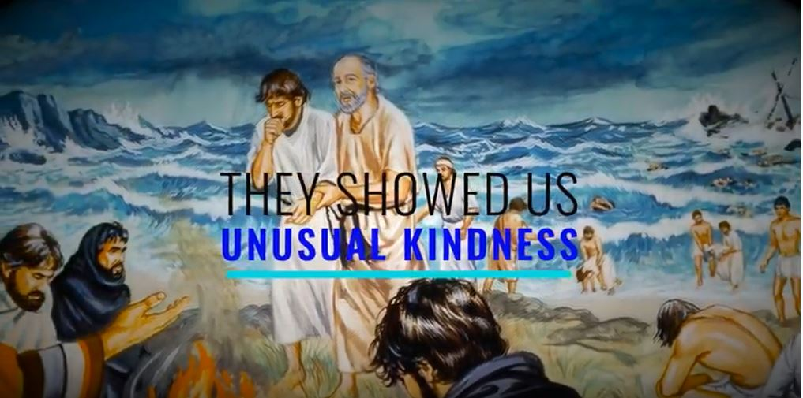

The Lord’s Prayer
We pray the prayer that Jesus taught us in unity recognising our diversity by praying in our chosen language,

Dismissal and Blessing Prayer

We are sent out together to proclaim the Good News.

We have come together as Christians, and therefore as fellow disciples.
As we yearn for Christian unity, let us commit ourselves anew to work for this common goal.

Pause for silent prayer.

The Church leaders who are present may join in proclaiming the Prayer of Blessing.

May God the Father, who called us from darkness into light,
make us true bearers of God’s light. Amen.

May God the Son, who redeemed us by his precious blood,
empower us to follow his example in serving others. Amen.

May God the Holy Spirit, who is Lord and giver of life, strengthen us to endure the shipwrecks of life and reach the shores of salvation. Amen.

May the Almighty and Merciful God, Father, Son and Holy Spirit,
bless and protect us now and forever. Amen.

We will set out together, to proclaim the wonders of God’s love.
Amen! Alleluia! Amen!

Concluding Hymn
HERE I AM LORD. Dan Schutte, SJ

I, the Lord of sea and sky,
I have heard My people cry.
All who dwell in dark and sin,
My hand will save.
I who made the stars of night,
I will make their darkness bright.
Who will bear My light to them?
Whom shall I send?

Here I am Lord. Is it I, Lord?

I have heard you calling in the night.

I will go, Lord, if you lead me.
I will hold your people in my heart

I, the Lord of snow and rain,
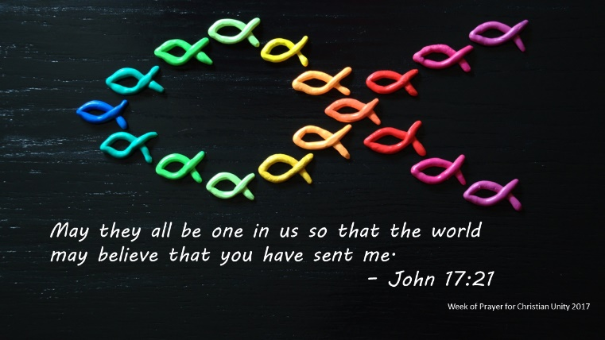
I have born my peoples pain.
I have wept for love of them,
They turn away.
I will break their hearts of stone,
Give them hearts for love alone.
I will speak My word to them
Whom shall I send?

I, the Lord of wind and flame,
I will tend the poor and lame.
I will set a feast for them,
My hand will save
Finest bread I will provide,
Till their hearts be satisfied.
I will give My life to them,
Whom shall I send?

